**Introduction To Computer Science 150005**

**Homework Assignment #13**

**Files**

**Question #1**

Define a function that is as passed an open file as a parameter. The function reads numbers from the file and returns their average.

Write a main program that reads input from 2 files: grade1.txt, grade2.txt, each containing a list of student grades. These files should be created manually in the executable folder (these files already exist in moodle). The program should output to the console the message highest average found in file and the index of the file which contains the highest average.

Example: For the following input files:

grade1.txt

grade2.txt

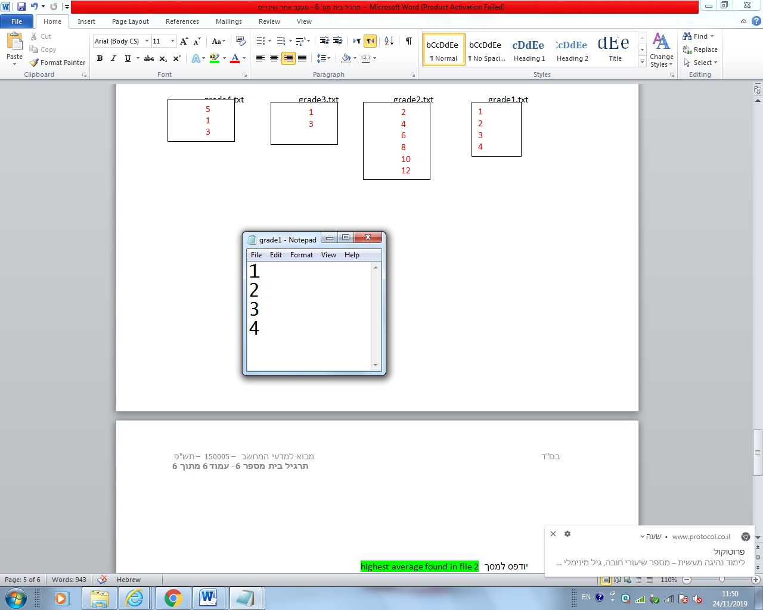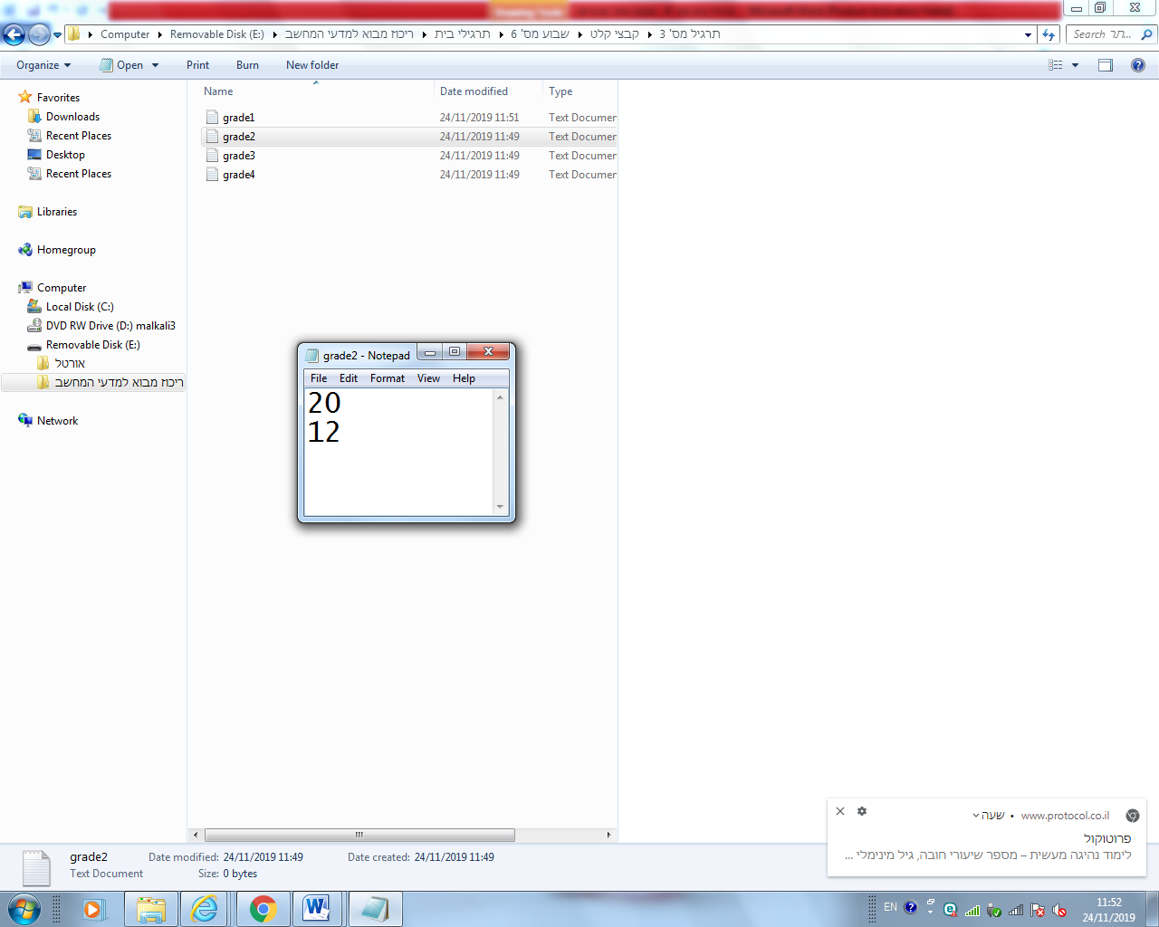

the output should is highest average found in file 2

**Question #2**

Definition: The frequency of an item is the number of times the item appears in a list. It can be calculated by counting the number of times it appears within the list. (Wikipedia)

Write a program that receives the name of a file from the user. The program should create a new file named **frequencyDigits.txt** and record in this file the frequency of all digits found in the input file.

The format of frequencyDigits.txt is as follows:

The first line is the header and contains the words **digit** and **frequency** separated by a space. The second line has the digit **0** and its frequency (the number of times the digit 0 appeared in the input file) again separated by a space.

In the next line, the number **1** and its frequency, and so on up to 9.

**You should print the output to the console as well.**

Example: If the input file was:

information.txt

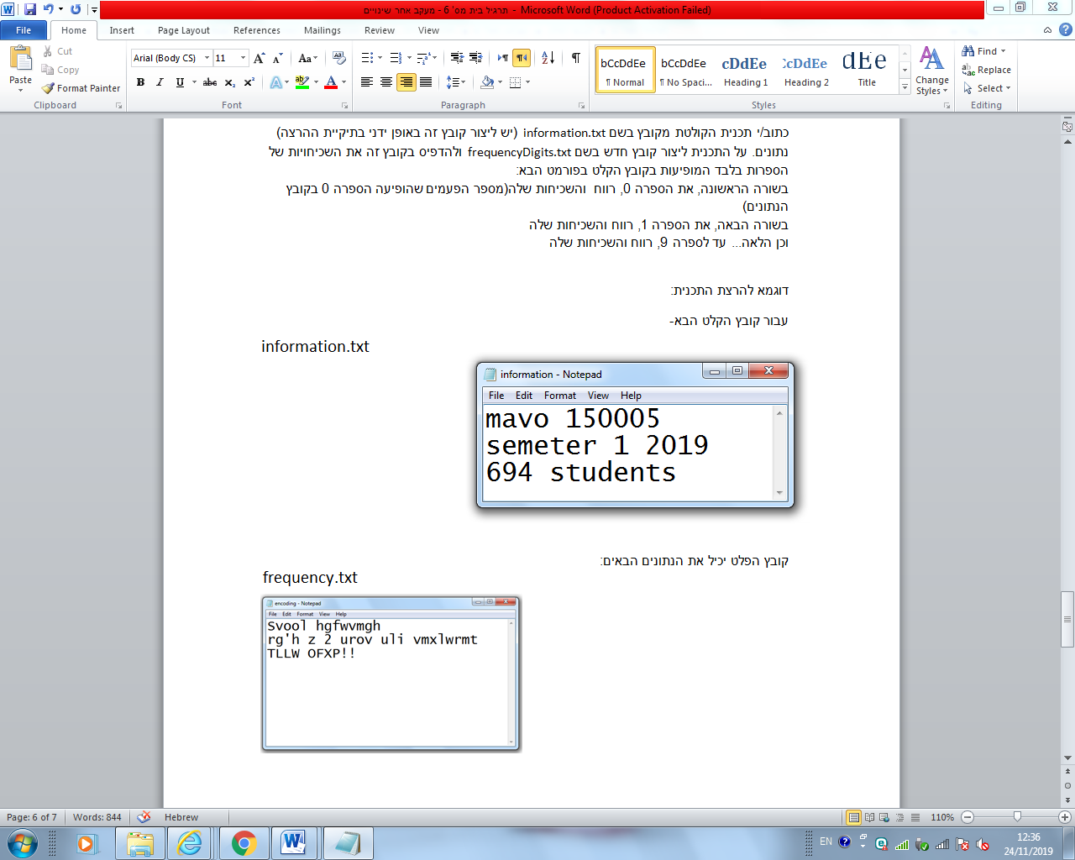

The output file frequencyDigits.txt (as well as the console) contains:

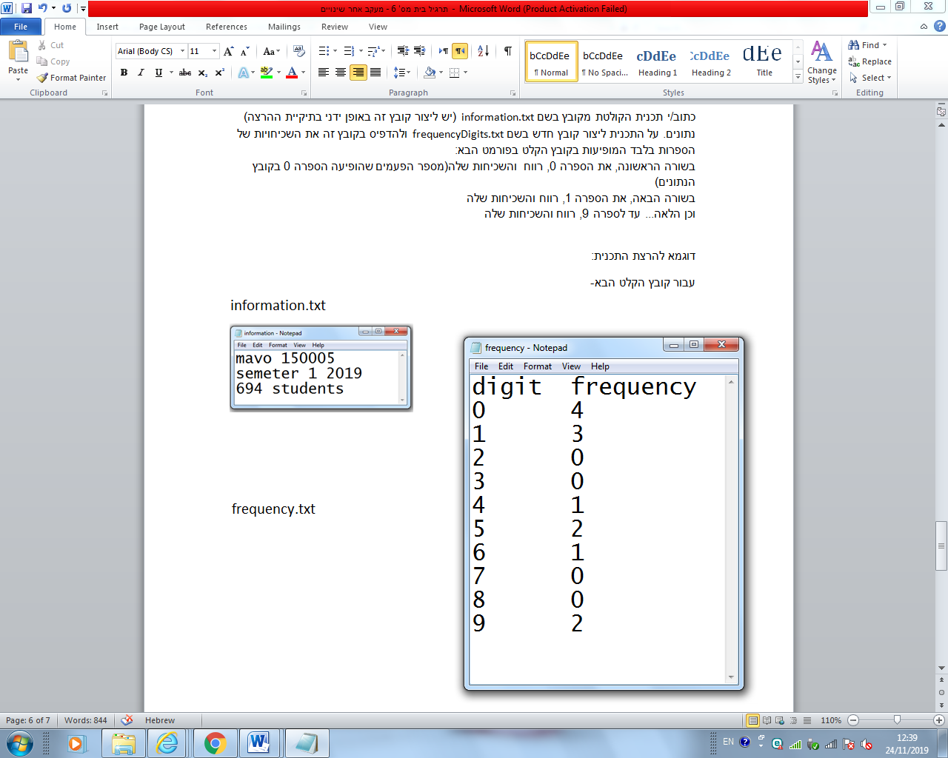frequencyDigits.txt